Book Proposal: Horsing Around
Overview
- Author: Ben Gilman
- Title: Horsing Around
- Genre: Fantasy comedy
- Length: 384 pages
Synopsis
The world of Mysteria is a thriving landscape of unity. The magical, mythical, supernatural, and “normal” live and love together in flawless harmony. Whether its humans and elves, dwarves and werewolves, or even vampires and fairies, the myriad of races and beings build friendships and families together in the longest known period of peace in Mysteria’s long history.
However, a dark shadow is cast over the people of Mysteria as a new political faction, the Humanity First Group, begin to spread anti integration propaganda among the population. Their main target is the Hybrids, the children born from relationships between two separate beings. Where do they come from? What do they want? And why does their mysterious and charismatic leader look so suspiciously like the Dark Lord who disappeared centuries ago?
Meet Magnus Horsson, a half Human, half Centaur Hybrid born at the height of peace in Mysteria. A rarity among Hybrids due to the notoriously reclusive nature of the Centaurs, Magnus is motivated by the prophecy told to his mother by a witch, shortly after his birth. The prophecy: a half Human, half Centaur Hybrid will unite the Centaurs back into society and defeat the Dark Lord.
However, due to an unfortunate bit of luck, Magnus was born with the top half of a Centaur, and the bottom half of a Human! With his very ordinary appearance, can Magnus convince anyone of his true heritage? Can he find the elusive and reclusive Centaurs? And can he unite the races of Mysteria and fulfil the prophecy?

Target Audience
The main target audience of Horsing Around is fans of the fantasy genre. Typically, fans of fantasy novels enjoy books that subvert the usual tropes of the genre, and Horsing Around’s satirical take on these tropes makes for an exciting and fresh read for readers who have read many serious fantasy novels. For example, the complex lore of several fantasy and supernatural beings living in harmony presents an interesting subversion of the usual isolationism of the races that is often a major feature of fantasy novels. This, with the unique addition of Hybrids, the children of two of the many different fantasy races in the story, creates an incredibly interesting world, one where many future adventures are possible, with a vast amount of potential Hybrid characters, both heroic and villainous, for fans to speculate about between releases of books set in this universe. A secondary target audience of Horsing Around is fans of Terry Pratchett’s Discworld novels. As Horsing Around is heavily influenced by Pratchett’s writing, the humour and the writing style in Horsing Around will be pleasantly reminiscent of Discworld to those reading it.
Comparable Titles
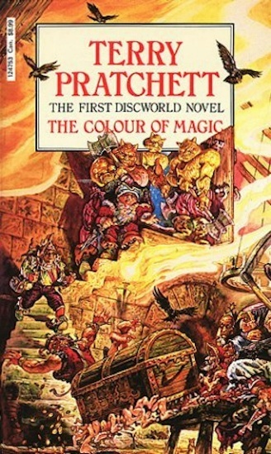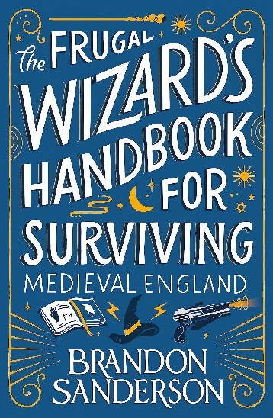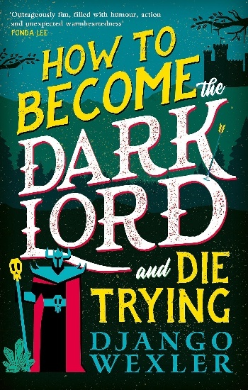
Regarding comparable titles to Horsing Around, the main one would be Terry Pratchett’s Discworld series. The satirical take on fantasy tropes and the use of footnotes, both for world-building and jokes, is very reminiscent of Pratchett’s writing, thus providing a feeling of nostalgia for Pratchett fans reading the book. Additionally, the depth and scale of the world-building and lore in Horsing Around provides a significant opportunity for many future stories set in the world of Mysteria, and a similarly large scope of different stories set in the world, like that of Discworld. More recently released novels that are comparable to Horsing Around include Brandon Sanderson’s The Frugal Wizard’s Guide to Surviving Medieval Britain, and Django Wexler’s How to Become the Dark Lord and Die Trying. Both books were very well received and reviewed based on their satirical use of fantasy tropes, and in particular Wexler’s use of footnotes in a similar manner to Pratchett. This shows that the humour and storytelling of Horsing Around can translate well to the target audience of both fans of fantasy novels, and those of Pratchett’s works.
Unique Selling Points

Conclusion
In conclusion, Horsing Around is a fascinating and exciting satire of fantasy tropes that boasts a significant potential for expansion through sequels and spin offs set in the same world. The world of Mysteria is intriguing and alluring, an almost Utopian fantasy world, where the unity is both fragile and the world’s biggest strength. Horsing Around also works as a standalone adventure for readers who do not want to be drawn into reading a large-scale fantasy series, a fun fantasy tale that can be picked up an enjoyed immensely by any reader.

