Book Proposal: The Voiceless
Overview
- Author: Ben Gilman
- Title: The Voiceless
- Genre: YA Dystopian Horror
- Length: 440 pages
Synopsis
“Help Me”
A man awakens to the sound of a cry for help so loud that it appears to echo inside his head. He realises that he in a mysterious facility, no possessions, no idea where he is, and most concerningly, no memory at all.
With the only clue to his identity being a number tattooed on his ankle, “384” explores the building he found himself in, slowly finding out more information about the horrific experiments that have taken place as he searches for the exit.
Upon finding the exit to the facility, “384” finds out the apocalyptic truth to his situation. The dead have risen, and the building belongs to MedCorp, a medical research group who hide their many dangerous human experiments behind the guise of “saving the world”.
“384” then finds the source of the mysterious cries for help, and the reason why it echoes so loudly and painfully inside his head. He can hear the thoughts of the dead.
As “384” travels through this dangerous new world, he meets many survivors of both the apocalypse and of MedCorp’s experiments, as their accounts and experiences bring to light the true horrors of the new world.
More memories begin to creep into “384”’s mind as he hears more and more thoughts from the dead. Will he find out the truth of MedCorp's experiments? Will he ever recover his identity? Why can he hear the thoughts of the dead? More importantly, why can the dead still think at all?

Target Audience
The main target audience for The Voiceless will be fans of YA Dystopian novels. With themes including a corrupt and evil corporation experimenting on people, a zombie apocalypse, and the friendships and relationships formed between the survivors, The Voiceless will have good standing amongst fans of similarly based YA novels.
Comparable Titles
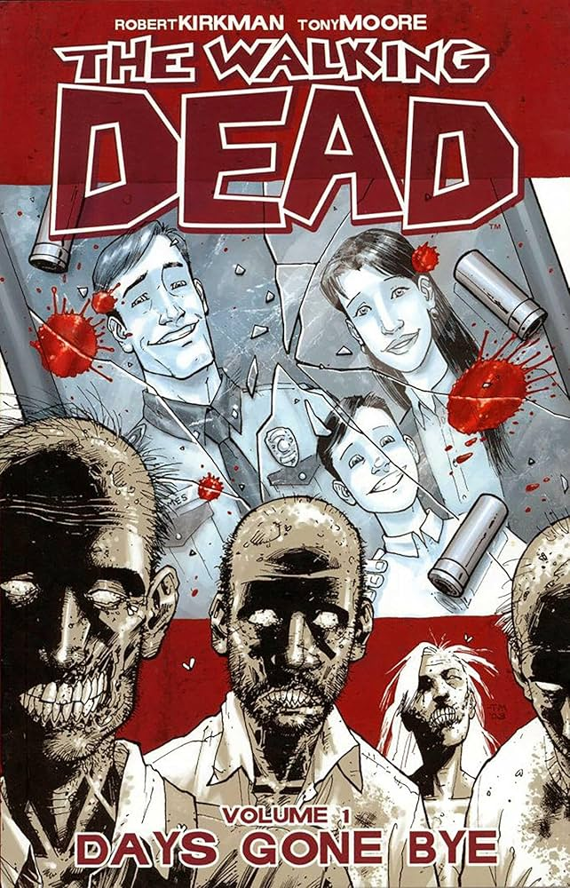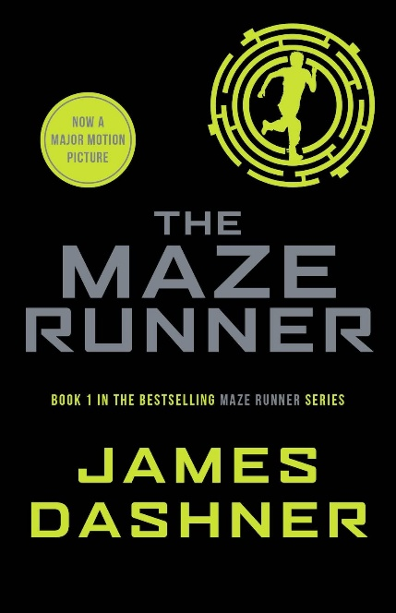
When considering comparable titles to The Voiceless, the most obvious would be The Walking Dead. The popularity and longevity of both the comic and television series has been a massively influential factor in the rise of zombie fiction. Naturally, The Voiceless has significant crossover appeal to fans of The Walking Dead, particularly in the focus on how the survivors interact with each other and the new world. Additionally, James Dashner’s The Maze Runner series features several similarities to The Voiceless. The YA target audience, the zombie-like apocalypse, and the government experimentation on the main character in to return the world back to normality will provide a sense of familiarity to fans of not just The Maze Runner, but also fans of other YA dystopia novels. As a common trope of the YA dystopia features the main characters fighting against the odds against a corrupt and powerful government or organisation, the story of The Voiceless is instantly recognisable to fans of YA dystopias, whilst also providing a fresh perspective on the common tropes through the unique horror take on said tropes. The first-person narration of The Voiceless is also an enticing factor to fans of other YA novels as it effectively places the reader into the action, thus the events feel more real to the audience.
Unique Selling Points
Zombie fiction is often told through two distinctive types of stories. In the first the zombies often play more of a background threat to the main characters, with the relationships between the survivors, both allies and enemies becoming the focus of the story. Alternatively, the body horror of the zombie can be the main priority of the story, with the desperate fight for survival in a bleak post-apocalyptic world providing a gripping and terrifying ride for the reader. The Voiceless uniquely finds itself squarely in the middle of the two styles of zombie fiction, as “384” has to both navigate a hellish world that he finds himself a newcomer in, whilst also finding himself within the terrifying clutches of the dead as he tries to understand the strange new powers that may be used to save the world. The Voiceless also provides a unique ethical dilemma to the story. Often in zombie media, the dead are no more than thoughtless cannon fodder, a threat that the main characters can kill swiftly and with no remorse. However, in The Voiceless, “384” quickly finds out, through his new powers, that the dead still retain the ability to think. Thus, every kill forced upon “384” is accompanied by a fresh wave of doubt, why can they still think? Do they have some humanity left inside them? And can they be cured of their affliction?
Conclusion
In conclusion, The Voiceless presents a fascinating new adventure in the YA dystopia genre. With a combination of fascinating powers, unique ethical questions in a difficult to navigate world, and shocking body horror, The Voiceless provides a compelling and gripping tale for fans of both zombie horror and YA dystopia novels.

