Book Proposal: Gifted
Overview of the book
- Author: Lee Lally
- Title: Gifted (working title)
- Genre: YA Fantasy
- Length: 384 pages
- Publication Date: 28th April 2026 (International Superhero Day)
- RRP: £8.99 (paperback)
- Publisher: Bloomsbury
About the Author
Lee Lally is a popular blogger, podcaster, and YouTuber, who boasts over 1 million combined subscribers and followers across YouTube, Spotify, and other social media platforms. Lee studied Creative Writing at the University of Manchester, before completing a Masters in Publishing at the University of Central Lancashire, an experience which he regularly attributes to inspiring his desire to talk about the creative process, using his social media presence and knowledge of the creative writing and publishing process to provide information to anyone in his audience who has dreams of becoming an author.
Lally has three significant outlets for his creative projects across social media and the internet. First, his blog, “Books and Me”, in which he reviews books he has read, both recently and from his childhood, mostly focusing on YA and fantasy novels to show the impact that a good read can have on a person’s mental health and wellbeing. Second, his podcast, “AniMe: How Anime can Inspire the West”, focuses on the current state of anime and manga as they release in Japan, both providing recommendations for any anime or manga fan on their next potential read or watch, but also giving examples of how western writers and illustrators can use storytelling techniques used in these mediums to expand their own writing styles. Third, his YouTube channel, “Do the Write Thing”, outlines the fundamentals of storytelling, giving advice on character writing, worldbuilding, and narrative structure.
Gifted is Lally’s debut novel, written after being struck by inspiration during the writing of an episode for his YouTube channel that focused primarily on how to write superheroes and superpowers. Lally additionally hopes for this book to be part one of a five-part story, should Gifted be popular enough.
Synopsis
To describe Cody Sims’ life as boring would be an understatement. A monotone job, distanced from his friends, who have all left for university, and non-existent love life leave Cody wistfully hoping for even the smallest adventure to spice up the last few of his teenage years. Then, one stormy day, when chasing down his errant, wind-blown umbrella down an alley, Cody comes across a mysterious, glowing orb of great value. Upon picking it up, a great rush of power flows through him, leaving him unconscious.
Waking up in the middle of a crater in a barren wasteland, Cody finds himself transported to a world vastly different from his own. No signs of the sprawling cities, nor the advanced technology that Cody has grown so dependent on seem to exist in this world. Even Cody’s phone has been fried in his journey!
However, this strange new world does have one perk that greatly interests Cody; superpowers! Hundreds of years prior, coinciding with a natural disaster that claimed the lives of hundreds of thousands of people, the inhabitants of this world began displaying supernatural abilities. Over the years, these began to be known only as “Gifts”.
Over the years, the Gifted mostly used their powers for good, building communities, defending the powerless from the rare Gifted people who used their powers for evil, and teaching future generations of gifted to use their burgeoning new powers. However, over time, a ruthless immortal dictator known only as The Undying rose to power throughout the land, forcing any Gifted who refused to serve in his forces to either flee or die where they stood.
To make things infinitely worse for Cody, the orb that brought him to this terrifying new world has attracted attention from the most dangerous place possible place possible. Powerless in a world he knows nothing about, Cody and his new friends, the flying twins Yanna and Yoel, and a mysterious teleporter known only as Blink, must avoid the grasp of The Undying’s most powerful lieutenants and reach the mythical sanctuary that the original Gifted are rumoured to have fled, the problem: no one alive has ever successfully reached this place.
Elevator Pitch
“Sometimes graverobbing has unintended consequences.”
The Publisher
Bloomsbury is an acclaimed publishing house which boasts an extensive catalogue of children’s YA fiction, including work from renowned authors such as JK Rowling and Neil Gaiman (Bloomsbury, n.d.). Although the back catalogue of YA fantasy novels features many examples of fantastic and popular novels in the genres of contemporary and historical fantasy, there is a clear gap in the market for a superhero novel, written for older YA readers. This book, full of action, emotion, and excitingly creative superpowers, is a fantastic fit for both YA readers, and for nostalgic adults, who grew up with the Marvel Cinematic Universe Movies.
Audience
Primary Audience: Teenage boys (16+)
- Themes of loneliness, change, and identity can relate to a school leaving age audience.
- Focuses on character development over spectacle, which fits into YA themes which generally focus on coming-of-age tales and on self-discovery (Yousef, 2023).
- Somewhat darker tone to stand out from other superhero related titles as ‘superhero fiction need not always be fun and colorful’ (Mušić, 2022)
Secondary Audience: Millennial fans of comic book movies
- Nostalgia among fans who grew up watching the Marvel Cinematic Universe, and reading the comics.
- Fits the age range for fans of the Marvel Cinematic Universe, which averages between 25 and 34, and are particularly active on social media (Osum, 2024).
- Provides a different perspective on superhero fiction, which would avoid the issue of superhero fatigue as ‘People aren’t tired of superheroes — they’re just tired of bad superhero movies.’ (Polo, 2023).
- Millennial parents of members of the primary audience who enjoy consuming superhero stories together.
Comparable Titles
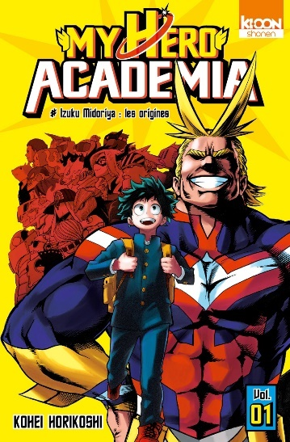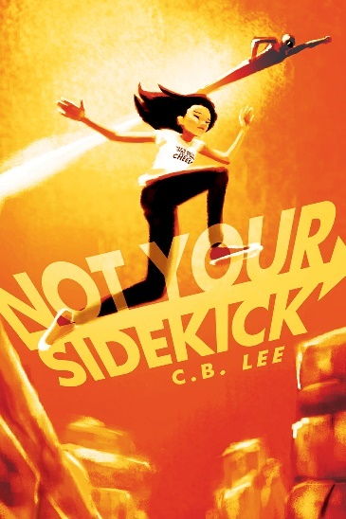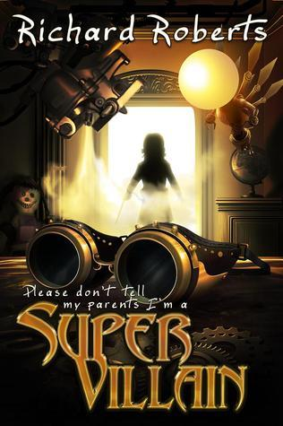
Regarding similar titles to Gifted, YA superhero novels that feature new characters and are targeted towards older YA readers appear to be somewhat limited. Whilst novels like “Not Your Sidekick” and “Please Don’t Tell My Parents I’m a Supervillain” have similar themes and a YA target audience, they are more aimed towards upper middle grade and younger YA readers. Although the older YA readers may gain some enjoyment in reading these stories, the lack of any stories with darker, more mature tones and themes represents a clear gap in the market which could easily be filled with Gifted.
Probably the clearest comparable title to gifted is the manga of “My Hero Academia”. This manga, later adapted into anime, is the story of a powerless boy who dreams of becoming the world’s greatest hero in a society where 80% of people have superpowers. It is evident that this features somewhat similar themes to Gifted, a powerless protagonist, themes of loneliness and identity. Published by Shueisha, and printed weekly in Shonen Jump Magazine, “My Hero Academia” is incredibly popular not only in Japan, but across the world, and over its ten-year, forty volume printing run it has sold over 100 million copies (Nakade, 2024). This almost unbelievable success is promising news for Gifted, as there are millions of fans of “My Hero Academia” who could be seen as potential readers of the book.
Unique Selling Points
Although the superhero movie market appears to be oversaturated in 2025, to the point of ‘superhero fatigue’ (James, 2023), the market for superhero related novels does not appear to have suffered this problem, particularly for the upper age range of YA novels, especially in novels that are not adaptations of previously established superheroes from the DC and Marvel brands. Thus, whilst YA superhero novels targeted towards younger readers have become fairly common, darker, more mature stories aimed towards older YA readers have been less so. Therefore, the darker tones in Gifted will provide a suitable alternative for in the older bracket for YA fiction.
Among the themes that Gifted will cover will be loneliness in the protagonist. This is an important theme to be used in a novel targeted towards older YA readers as not only are young people who have suffered with loneliness less likely to be in full time education, but they are also more likely to be of a lower social status (Fawehinmi, 2024). As Cody suffers with feelings of loneliness throughout the story, first through the isolation of being the only member of his friend group who has not gone to university, then as the only member of his group in the other world without superpowers, his character has a unique potential to resonate with the target audience of recent school leavers, who are navigating important and difficult changes to their routines and personal lives. Thus, having such a character to relate to could prove to be lifechanging for any young reader who needs it.
Future Potential
Gifted presents a considerably large potential for future publication. Lally has already outlined the potential for four sequels to the story, should the book prove to be popular. These would add more characters, more creative superpowers, and more connections between the heroes and villains of the story, whilst also advancing Cody’s story and character through several new and exciting adventures. Additionally, Lally has presented multiple ideas for prequel spin off books based upon the mythology of the world that Cody finds himself in. These books would be loosely based upon the Greek myths of our world, but with a superhero twist. The influence of manga and anime on the book also raises the potential for it, and any sequels, to be adapted into graphic novels, as the visuals of superpowers will translate well into the medium, with the right illustrator.
Marketing, PR and Sales
As Lally boasts a significant social media presence, he will be invaluable in the promoting of Gifted. However, it would be wise to use his connections and other outlets to ensure that the book has the greatest reach possible before publication.
Social Media
- Lally to utilise a countdown on his Twitter, Facebook, Instagram and TikTok profiles to build up hype for the announcement of the book, this will be done by revealing the cover.
- On his YouTube channel, Lally can start using brief excerpts from Gifted as examples during videos about storytelling.
- Book trailers to be made to build hype for the novel in the months leading to the release of the book, both in video form for use on his YouTube channel, and in audio form to be played before every episode of his podcast.
Influencers
Multiple influencers will be contacted to promote the book in the build up to release day. The focus will be on YA influencers across blogs, Instagram and TikTok, particularly those invested in YA and superhero influencers. Proof copies will be sent to each influencer, along with complimentary branded bookmarks and tote bags. Influencers will include:
Blogs
The Candid Cover: The Candid Cover | a Canadian (YA) young adult book blog
Confessions of a YA Reader: The Candid Cover | a Canadian (YA) young adult book blog
Book Riot: Young Adult Literature Archives - BOOK RIOT
Forever Young Adult: Blog - Forever Young Adult
Instagram
I Read YA: I read YA 📚 (@ireadya) • Instagram photos and videos
YA Bools Central: YA Books Central (@yabookscentral) • Instagram photos and videos
Tilly Loves Books: Tilly Loves Books | Bookstagram (@tillylovesbooks) • Instagram photos and videos
YA Reads: Young Adult Reads (@y.a.reads) • Instagram photos and videos
TikTok
Hi…I’mABookaholic: Hi…I’mABookaholic (@bookaholicalways) | TikTok
Mias.bookcase: mia ➶ (@mias.bookcase) | TikTok
Chronicallybookish: Kaley 📚 (@chronicallybookish) | TikTok
Thtgrlreads: Jaimee 🧚‍♂️ 🐉 🩵 (@thtgrlreads) | TikTok
Events
- Lally to produce series of special episodes of his podcast detailing the process of writing, editing, and publishing the book. These episodes will also be uploaded to his YouTube channel.
- Book launch at Waterstones Manchester Arndale on 27th April 2026 at 8pm, PoS material sent out in advance, including posters, bookmarks and tote bags. This will be a ticketed event with prices being £5 for entry, or £15 to include a signed copy of the book and a free bookmark and tote bag. The event will include a live reading of the first two chapters of the book.
- As the book is being released on International Superhero Day, a special launch day discount of 10% will be offered to “real life superheroes”, including NHS workers, first responders, teachers, etc.
- Expected budget for launch event and packages sent to influencers to be around £700
Profit and Loss
Given the considerable size of Lally’s online following, I would recommend an ambitious first printing run of 5,000 copies. This will give the book a good chance at making a decent amount of profit and will be a reliable marker to determine not only if it is successful enough to allow for further print runs, but also the viability of publishing future sequels in the near future. Lee Lally has declined the offer of a £1,000 advance, due to the considerable of money he receives from advertisements he receives from his various side projects.
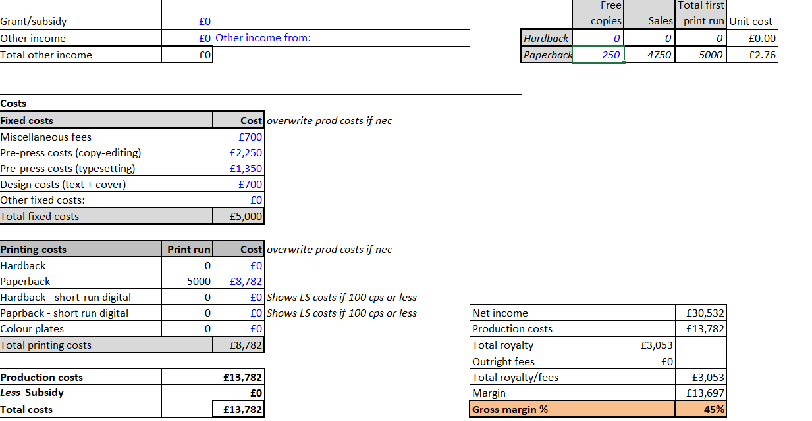
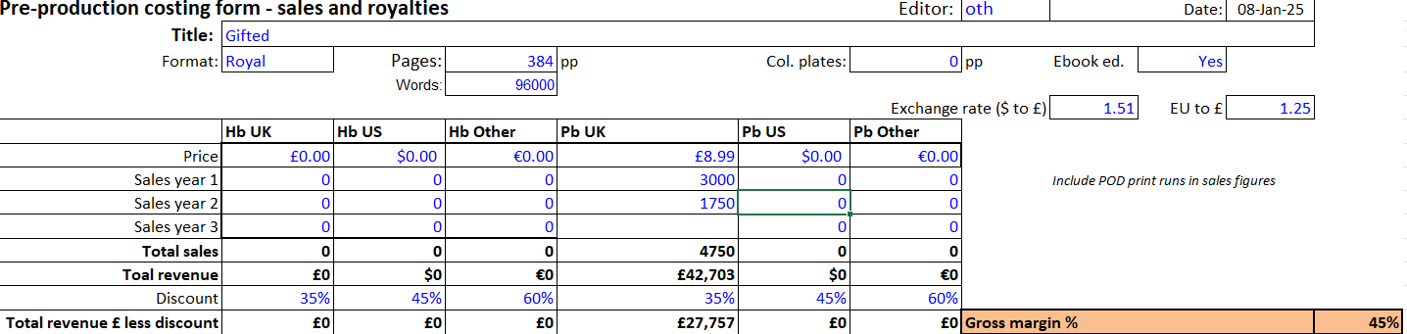
As seen in the pictures above, if over two years, the 5000 copy print run of Gifted sells out completely, including free copies sent too the author, reviewers etc., this will see a profit of 40%. I feel like this would be considered an incredible success for a first-time author, and would definitely be worthy of greenlighting future print runs, sequels, special editions, etc.
Conclusion
Gifted is an excellent investment for publication. With characters and themes that appeal both to school leavers at an awkward and difficult period of their lives, and millennial fans of comic book movies reading with nostalgia of their youths spent watching Marvel Cinematic Universe movies and reading superhero comics, gifted boasts a broad appeal that will leave readers wondering why they ever believed in “superhero fatigue”. Gifted not only has potential to be a very successful standalone novel, but also to be the first story in a vast catalogue of sequels, spin offs, prequels, and graphic novels. I feel that Gifted is the beginning of big things to come from Lee Lally.
Reference list
James , J. (2023). Marvel’s Oversaturation: When Quantity Hurts Quality. [online] The Catalyst. Available at: https://recatalyst.org/3941/arts/marvels-oversaturation-when-quantity-hurts-quality/.
Mušić, D. (2022). Theory of Fantasy Literature 102: On Superhero Fiction. [online] Arcadia. Available at: https://www.byarcadia.org/post/theory-of-fantasy-literature-102-on-superhero-fiction.
Nakade, U. (2024). My Hero Academia Manga Sells Over 100 Million Copies - OtakuKart. [online] OtakuKart. Available at: https://otakukart.com/my-hero-academia-manga-sells-over-100-million-copies/ [Accessed 8 Jan. 2025].
Osum. (2024). Cracking the Code: Marvels Target Audience Demystified - Osum. [online] Available at: https://blog.osum.com/marvel-target-audience/.
Polo, S. (2023). People aren’t tired of superheroes, they’re tired of bad superhero movies. [online] Polygon. Available at: https://www.polygon.com/24016931/superhero-fatigue-movie-flops-2023-mcu-dceu.
www.bloomsbury.com. (n.d.). Overview. [online] Available at: https://www.bloomsbury.com/uk/connect/about-us/overview/.
Yolanthe Fawehinmi (2024). Is your teenager lonely? The warning signs and how to support them. [online] The Independent. Available at: https://www.independent.co.uk/life-style/health-and-families/loneliness-neuroscience-university-of-greenwich-kcl-cbt-b2513269.html [Accessed 8 Jan. 2025].
Yousef, Z. (2023). YA Fantasy vs Adult Fantasy: Which Should You Write? [online] Zainah Yousef. Available at: https://zainahyousef.com/blog/ya-fantasy-vs-adult-fantasy-which-should-you-write/.
Image Sources:
My Hero Academia: my hero academia manga - Search Images
Not Your Sidekick: Not Your Sidekick (Sidekick Squad, #1) by C.B. Lee | Goodreads
Please Don’t Tell My Parents I’m a Supervillain: Please Don't Tell My Parents I'm a Supervillain by Richard Roberts | Goodreads

