Book Proposal: Future Proof
Overview
- Author: Ben Gilman
- Title: Future Proof
- Genre: Mystery Novella
- Length: 184 pages
Synopsis
You wake up in a daze, with no memories of the previous night. Oddly, you appear to have slept at your desk, even more oddly, a ripped-out page of a diary sits on the desk in front of you, bearing today’s date. You notice your own handwriting scrawled across the page, a description of a rather mundane, regular day that you have played through hundreds of times in your life. Was it a writing exercise you forgot about? How did you remember every detail of a long gone, boring day, but not the events of the previous night?
To your great surprise, the next day plays out exactly how you wrote it in the diary. Odd? Yes, but nothing to extraordinary, the events you wrote about were all regular occurrences in your life, a strange coincidence for sure. Imagine your shock and dismay then, when you wake up the next morning with another diary page in front of you on your desk. You read in horror as this day is far from ordinary. The day you read about goes increasingly wrong, until you eventually find yourself with blood on your hands, and a body in front of you. Surely this one can’t be true? And if it is, your knowledge of this day will help you avoid its disastrous consequences?
There’s blood on your hands. No matter what you tried, the events you read about in the morning came to pass, and now someone is dead at your hands. Who is doing this to you? Will there be more horrifying days in your future that you can’t escape? Can you find the source of this new cursed existence and return to your old life?
Target Audience
The main target audience for Future Proof will be influencers across social media platforms such as TikTok and Instagram. The short form storytelling of the novella, the experimental prose of the narration, and the dark magic infused mystery will be an enthralling read for both influencers and their fans. Social media is ever increasing in value in terms of marketing and creating hype in the publishing world and providing the creatives of BookTok and Bookstagram with such a fascinating premise both gives said creatives an excellent opportunity for great content, but also a strong platform for Future Proof to become a best seller.
Comparable Titles
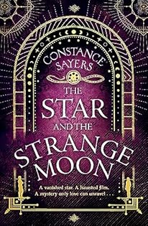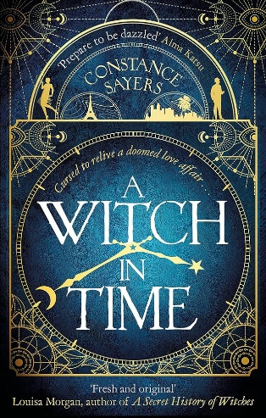
Regarding comparable titles to Future Proof, Constance Sayers’ work such as The Star and the Strange Moon and A Witch In Time contain somewhat similar themes and storytelling. The unfolding mystery, touched by dark magic, in Future proof, is hauntingly familiar to fans of Sayers’ books, and the increased publicity of Future proof through social media will naturally entice these fans towards it. Additionally, Uketsu’s Strange Pictures and Strange Houses are significantly comparable to Future Proof. Both gripping short form mysteries that engage the reader, whilst slowly giving clues and answers through uniquely written prose, the vast popularity of these books show how uniquely written mysteries like Future Proof can command the attention of readers across the world. Additionally, Uketsu’s success in marketing the books as a popular YouTuber shows the clear potential for Future Proof to be a success through its target audience.
Unique Selling Points
Future Proof’s greatest strength comes from its unique blend of narrative styles. Second person, future tense narration is incredibly rare and unconventional in fiction, due to the difficulties of maintaining the style for an entire novel. As Future Proof switches between second and first person narration whether the diary is being read or not, not only does the prose not entirely rely on the second person narration for the whole book, but the switching between styles creates contrasting feelings of dread as the diary entries are read and frantic desperation as the first person narrator tries hopelessly to defy the dire predictions they read. This unique storytelling style is also a valuable asset when marketing the book, as it provides social media influencers a fascinating subject to talk about when reviewing the book.
Conclusion
In conclusion, Future Proof is a massively experimental book, both in writing style and in marketing. The recent success similarly experimental and unique books, combined with the marketing campaign directly through the ever growing influence of social media, make Future Proof an exciting new novella that could revolutionise how books are written and marketed.

